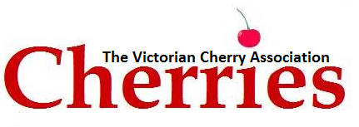

The Victorian Cherry Association is delighted to invite your organisation to become an Affiliate Member of the VCA.
Our focus is partnerships that provide useful information for our members, as well as an opportunity to demonstrate your expertise. The VCA provides the best avenue to reach cherry growers via our fortnightly E-Newsletter as well as the VCA website.
Investing in the VCA’s communication platform ensures you can be confident your message is reaching a targeted and focused market within the Victorian Cherry Industry.

Affiliate Membership Benefits – 2022/23 $2000.00 (inc. gst)

Designed specifically for companies, businesses, suppliers and individuals aligned or working with and supporting the cherry growing industry.
The following benefits are provided to Affiliate members:
- 1 year subscription to the VCA Newsletter
- Invitation to attend VCA events eg. AGM, Grower Meeting, Season Review
- 5 Free advertisements in the VCA Newsletter
- Company logo and hyperlink in Newsletter and on VCA website
- Access to the VCA bulk mailing list via VCA for promotional purposes. Electronic mailing is free, mail is cost of envelopes and postage and VCA staff time.
- Acknowledgement of industry support in the annual report.

Please complete the attached Application form and email to info@cherries.org.au.

Kind Regards,

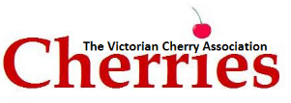
P.O. Box 612, Mooroopna Vic 3629
Ph: 03 5825 3700 Email: info@cherries.org.au

APPLICATION FOR AFFILIATE MEMBERSHIP

Please use BLOCK letters throughout

Company Name

Contact Name

First Name Last Name
Postal Address (Please include Postcode)

Business Address (Please include Postcode)

Telephone Contact Details

Business Hours After Hours

Mobile Other

Email address (this address will be added to the VCA Newsletter mailing list)

Accounts Contact & Email address

AFFILIATE MEMBERSHIP
$2000.00 inc. GST

Payment can be made via EFT or cheque upon receipt of Invoice.
EFT: National Australia Bank - BSB: 083-739 Acc: 51-883-2418 (Please include Name and Invoice Number with payment)

The above named hereby applies for affiliate membership of the Victorian Cherry Association and agrees to pay the membership fee applicable.

Signature Date

